MENTORLINK
Prepared by: group 5

INTRODUCTION
MENTORLINK is a platform designed to connects students to experienced mentors, providing professionals the opportunity to monetize their skill. The platform serves as hub for tech-driven individuals to communicate, book sessions, and establish meaningful mentorship relationship. By streamlining payment method, and removing traditional barriers to entry, MENTORLINK provides fast, easy, reliable and flexible way for students to access guidance they need to succeed.
SYSTEM OVERVIEW
- Purpose of the system
The system is a web-based platform design to connect student with experienced mentors for academic and career guidance. It allows users to register, browse mentors, book sessions, and make payments online.

- System scope
The system includes users’ registration, mentor profile management, session booking, and payment processing, it does not include offline mentoring or third-party certification system.
- High level Architecture
The system follows a client-server architecture. The frontend is developed using modern web technologies to provide an interactive user interface. The backend handles business logic, authentication, and communication with the database, where all user and session data are stored.
- Main components/ Models
The system consists of the following main modules:
- User authentication module (login/signup)
- Mentor management module
- Booking system
- Payment integration
- Admin dashboard
- User Role
The system supports three main user roles:
- Admin: Manages users, mentors, and system data
- Mentor: Creates profile, sets availability, and manage session
- Student/ User: Searches mentor, books sessions, and make payments
- System workflow
Users create an account and log in. They can browse available mentors, select a preferred mentor, and book a session based on availability. Payments are processed online, and both users receive confirmation notification.
- Technological use
The system is built using HTML, CSS, JavaScript for the frontend, and a backend framework with relational database for data storage

SYSTEM ARCHITECTURE
- Overview of the architecture
The MENTORLINK system follows a client-server architecture that separates the user interface, application logic, and data storage into distinct layers. The separation improves scalability, maintainability, and performance
- Architecture type
The system is designed using a three-tier architecture consisting of the presentation layer, application layer, and data layer.
- Main components of the system
- Presentation layer (Frontend): The presentation layer is built using HTML, CSS, JavaScript. It provides an interactive interface where users can register, search for mentors, and manage sessions.
- Application layer (Backend): The backend handles business logic such as authentication, session scheduling, and payment processing. It processes user request and communicates it with the database. It is build using…………
- Data layer (Database): The database stores user information, mentor profile, bookings, and transaction records. It ensures data consistency and secure storage. It is built using……...
- System interaction/ Data flow
when a user submits a request (e.g., booking a mentor), the frontend send the request to the backend server via an API. The backend processes the request, interacts with the database to store or retrieve data, and sends a response back to the frontend for display
- External integration
The system integrates with mobile payment service to facilitate secure transaction between students and mentors.
- Security consideration
The system implements authentication and authorization mechanisms to ensure secure access, and user data is protected through secure API communication.

Some architecture diagrams include
- Activity diagram
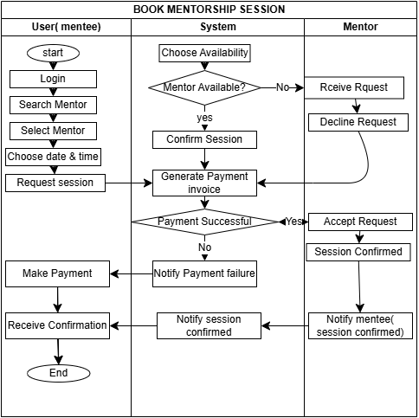

- Usecase diagram
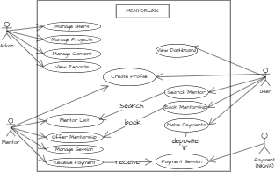
FUNCTIONAL REQUIREMENTS
- Definition: Functional requirement describes the specific feature and operations that the system must perform. They define how users interact with the system responds to those actions.
- Functional requirements organize by user role
FR-1. Students’ functional requirements
- They system shall allow student to register an account
- They system shall allow students to login securely
- They system shall allow students to search for mentors based on skills or categories
- The system shall allow students to view mento profiles
- The system shall enable students to book mentorship sessions
- The system shall allow student to make payment using mobile payment using mobile payment system (e.g., Momo).
- The system shall allow students to view their booking history
FR-2. Mentors’ functional requirement
- The system shall allow mentors to create and manage their profile
- The system shall allow enable mentors to set availability for sessions
- The system shall allow mentors to accept or decline booking requests
- The system shall allow mentors to view scheduled session
FR-3. Admin functional requirement
- The system shall allow the administrator to manage user account
- The system shall enable the administrator to monitor platform activities
- The system shall enable the administrator to remove or suspend users.
FR-4. Other company
The functional requirements outlined above define he core operation of MENTORLINK system. They ensure that all users-students, mentor, companies and administrator-can effectively interact with the platform and perform their respective tasks
NON-FUNCTIONAL REQUIREMENT
- Definition: Non-functional requirements describe the quality attribute and performance standards of the system. They define how the system operates rather than what it does
- Categories of non-functional requirement
NFR-1. Performance requirement
- The system shall load all main pages within 3 seconds under normal condition
- The system shall support at least 100 concurrent users without performance degradation.
NFR-2. Security requirements
- The system shall require user authentication for secure access
- The system shall encrypt sensitive user data
- The system shall protect unauthorized access and common web attacks
NFR-3. Usability requirement
- The system shall provide user-friendly interface
- The system shall be easy to navigate for both student and mentors
- Users shall be able to complete key task (e.g., booking a session) within a few steps
NFR-4. Reliability and availability requirement
- The system shall be available 99%of the time
- The system shall handle errors gracefully without crashing
NFR-5. Scalability
- The system shall be able to scale to accommodate increasing numbers of users and data
NFR-6. Compatibility:
- The system shall be accessible by modern web browser (chrome, edge, safari)
- The system shall be responsive across mobile, tablet, desktop devices
NFR-7. Maintainability
- The system shall be modular to allow easy update and maintenance
- The codebase shall follow standard coding practice for readability
DATABASE DESIGN
- Introduction (purpose of database)
The database is design to store, organize and manage all data required by the MENTORLINK system, including user information, mentor profiles, company profile, booking, and transactions. It ensures data consistency, security and efficient retrieval.
- Database type
The system uses a relational database where data id stored in tables with defined relationship
- Database structure overview
The database structured into multiple tables representing different entity of the system. Each table contains fields the define the properties of data, and relationship are established using primary and foreign keys.
- Key tables
- Users table
Stores general information (students, mentors, admin, companies)
- User_id (primary key)
- Name
- Email
- Password
- Role
- Mentors table
Stores mentor-specific details
- Mentor_id (primary key)
- User_id (foreign key)
- Skills experience
- Availability
- Booking table
Handle session scheduling
- Booking_id (primary key)
- Student_id (foreign key)
- Mentor_id (foreign key)
- Date
- Status
- Payment table
Stores transaction records
- Payment_id (primary key)
- Student_id (foreign key)
- Mentor_id (foreign key)
- Amount
- Pay_method
- Payment_status
- Relationship between tables
User table links to the mentors and student roles through the User_id field. The booking table connects students and mentors using foreign keys while the payment table is linked to the booking table to track financial transactions
- Database design principles
The database follows normalization principles to reduce redundancy and ensure data integrity primary and foreign keys used to maintain relationship between tables
- Simple diagram reference
An Entity -Relationship (ER) diagram is used to visually represent the database structures and relationship between entities
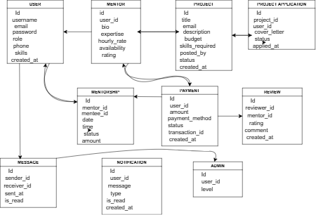

UI DESIGN
- Introduction
The User interface (UI) design of the MENTORLINK system focuses on creating an intuitive, responsive, and visually appealing interface that enhances the user experience or students, mentors, companies and administrators. The design ensures ease of navigation and accessibility across different devices
- Design goals
The UI design aims to:
- Provide a simple and user-friendly interface
- Ensure easy navigation between pages
- Maintain visual consistency across the system
- Supports mobile, tablet, and desktop responsiveness
- Enhance user engagement and accessibility
- Layout structure
The system uses a structured layout consisting of:
- Navigation bar (Header): Contains links to the main pages
- Main content area: Display page-specific information
- Sidebar: show additional options like dashboard tools
- Footer: Contains contact information, links, and copyright
- Key pages UI design
- Home page
- Display hero section introducing MENTORLINK
- Highlight key features of the platform
- Provides call-to-action buttons (Sing Up/Find Mentor)
- Login/Registration page
- Simple form-based layout
- Minimal distraction for easy authentication
- Input validation for user data
- Dashboard (Student/Mentor/Admin)
- Personalized interface based on user role
- Quick access to key features (bookings, messages, profiles)
- Clean card-based layout for information display
- Mentor profile page
- Display mentor information (skills, experience, availability)
Includes “Book Session” button for interaction
- UI design principles used
The UI design follows modern design principles such as:
- Consistency In colors an fonts
- Simplicity and minimalism
- Responsive design for different screen size
- Clear visual hierarchy (important element stand out)
- Accessibility considerations for all users
- Color scheme and Typography
The system uses a clean and modern color palette to ensure readability and professionalism. Fonts are chosen for clarity and ease of reading, with consistent styling across all page
- Responsiveness
The UI is design to be responsive, ensuring that the platform functions effectively on desktop, tablets, and mobile devices without loss of usability or structure
- Some screenshots
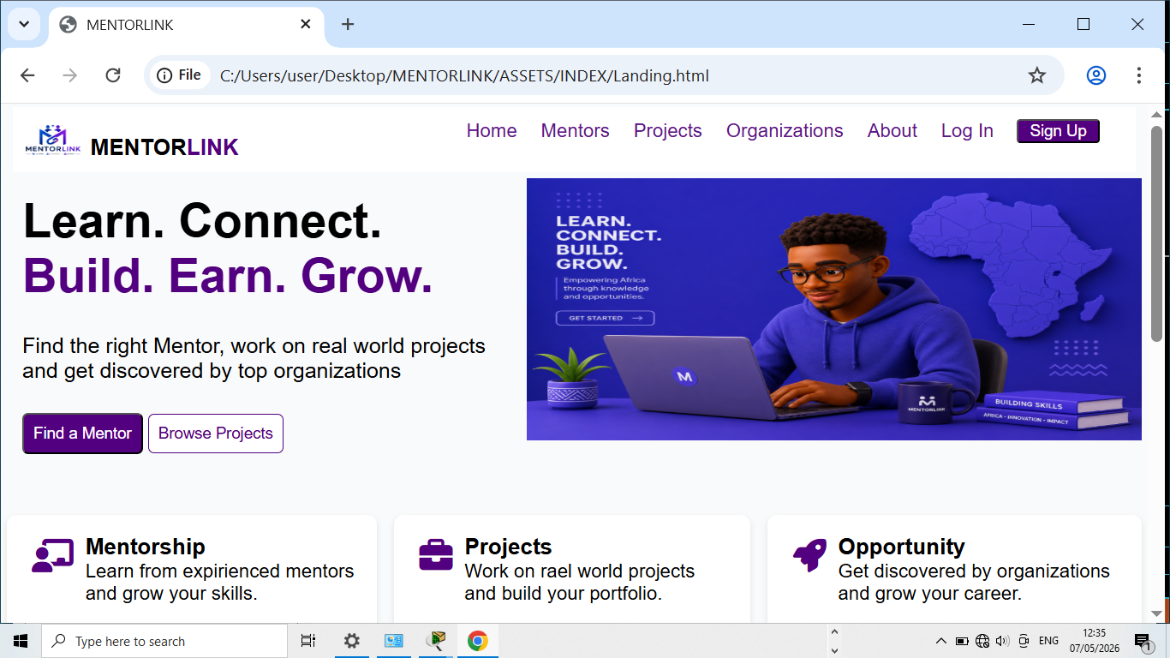
USER FLOW
- Introduction
User flow describes the path user follow when interaction with the system to complete specific tasks. It shows the sequence of steps from the entry into system to achieve a goal
- Purpose of user flow
The purpose of the user flow is to ensure a smooth and logical navigation experience for users, reduce confusion, and improve usability within the MENTORLINK platform
- Identify user type
- Students
- Mentor
- Companies
- Admin
- Main user flow
- Student user flow
- User visit the website
- User registers or logs in
- User is redirected to dashboard
- User search for a mentor
- User view a mentor profile
- User books a session
- User makes payment (if required)
- User receives confirmation
- Mentor user flow
- Mentor logs in
- Mentor accesses dashboard
- Mentor updates profile and availability
- Mentor receives booking requestion
- Mentor accepts or decline session
- Mentor view schedule sessions
- Companies’ user flow
- Company logs in
- Company accesses dashboard
- Company updates profile and availability of project
- Company receives CV requestion
- Company accepts or decline the CV
- Company views schedule sessions

- Admin user flow
- Admin logs in
- Admin accesses admin dashboard
- Admin manages users (students/mentors/companies)
- Admin monitors platform activity
- Admin handles report or issues
- Visual representation
Flow chat diagram
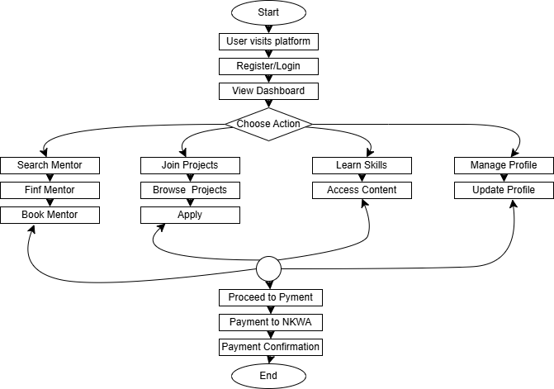
API DESIGN
- Introduction
The API (Application Programming Interface) of MENTORLINK system enables communication between the frontend and backend. It allows the system to send, receive, and process data such as user information, mentor profile, bookings, and payments
- Purpose of the API
The API is responsible for handling request from the client side, processing business logic on the server, and returning appropriate responses. It ensures smooth data exchange between the user interface and the database
- API Architecture style
The system uses a RESTful API architecture, where data Is exchanged using standard HTTP methods such as GET, POST, PUT, and DELETE
- API endpoint
- User authentication
- POST/api/register Register a new user
- POST/api/login Authenticate user
- Mentor management
- GET/api/mentors Retrieve all mentors
- GET/api/mentors/:id Get more details
- POST/api/mentors Create mentor profile
- POSTT/api/mentors/:id Update mentor profile
- Booking system
- POST/api/bookings Create a booking
- GET/api/bookings/user/:id Get user bookings
- PUT/api/bookings/id Update booking status
- Payments
- POST/api/payment/:id Process payment
- GET/api/payment/:id Retrieve payment details

- Request and response format
Request (login)
{ “email”: nenefavour@gmail.com,
“password”: “1234” }
Response
{ “message”: “login successful”,
“token”: “abc123xyz” }
- Authentication and security
The API uses token-based authentication. User must include a valid token in the request header to access protection routes.
- Error handling
The API returns appropriate HTTP status codes:
- 200 --> success
- 201 --> created
- 400 --> bad request
- 401 --> unauthorized
- 404 --> not found
- 500 --> sever error
- Data flow
When a user performs an action (e.g., booking a mentor), the frontend sends a request to the API, which processes it, interact with the database, and return a response to the frontend
SECURITY
- Introduction
The security component of the MENTORLINK system ensure that users data, system resources, and transaction are protected from unauthorized access, misuse, and data breaches. It implements mechanisms to maintain confidentiality, integrity, and availability of information
- Authentication (who are you?)
The system uses a secure authentication mechanism where users must provide valid credentials (email and password) before accessing the platform. Passwords are encrypted and stored in the database
- Authorization (what can you do?)
The system implements role-based access control (RBAC), ensuring that users can only access feature permitted to their role:
- Students can book and view mentors
- Mentors can manage profile and session, apply to join project
- Companies can manage profile and post projects
- Admins can manage users and system data
- Data protection
Sensitive data such as password and payment information are protected using encryption techniques. The system ensure that data is securely stored and not exposed to unauthorized users
- Secure communication
All communication between the client and the sever is handled over secure protocol (HTTPS), ensuring that data transmitted between the browser and server is encrypted
- Input validation and protection

The system validates all user input to prevent malicious activities such as SQL injection and cross-scripting (XSS). Only properly formatted and safe data is processed by the backend
- Session Management
User session are managed securely using tokens, which expire after a define period of interactivity to prevent unauthorizes access
- Error handling
The system designed to avoid exposing sensitive system information in error message, reducing security risks
TESTING
- Introduction
Testing is the processes of evaluating the MENTORLINK platform to ensure that all functionalities work as expected and meet the specified requirements. It helps identity errors, verify system behavior, and improve reliability before deployment
- Purpose of testing
The purpose of testing is to ensure that the system is functional, secure, user-friendly, and performs efficiently under different conditions
- Types of testing used
- Unit testing
Individual components of the system (such as login, registration, and booking functions) were tested separately to ensure they work correctly
- Integrated testing
This ensures that different modules (frontend, backend, database) work together properly. For example, booking a mentor correctly updates the data base and reflects on the dashboard
- System testing
Th complete system was tested as a whole to verify that all features function correctly in real-world scenario
- User acceptance testing
End user (students and mentors) tested the system to confirm that it meets their needs and easy to use
- Test cases
Test case | Description | Input | Expected output | Result
TC1 | User login | Valid email & password | Redirect to dashboard | Passed
TC2 | Mentor search | Enter skill keyword | Display matching mentors | Passed
TC3 | Booking session | Selection mentor & data | Booking confirmation | Passed
TC4 | payment | Valid momo payment | Payment successful messages | Passed
- Testing tools
The system was tested manually using browser-based testing too and developer tools for debugging and validation
- Bug testing/ error handling
During testing, minor issues such as form validation errors, UI alignment problems were identified and corrected to improve system stability.
- Testing results summary
All major functionalities of the MENTORLINK system passed testing successfully. The system performed as expected in terms of functionality, usability, and performance
DEPLOYMENT
- Introduction
Deployment is the process of making the MENTORLINK system available for use by hosting it on a server or cloud platform. It involves transferring the completed application from the development environment to an environment where users can access it
- Deployment environment
The MENTORLINK system is deployed on a web server allowing users to access it through a web browser via a URL
- Hosting platform
Netifly
- Deployment process
The deployment process includes:
- Building the application for production
- Uploading the frontend files to a hosting platform
- Configuring backend server and database connection
- Setting environment variables
- Testing the live system to ensure proper functionality
- Database deployment
The system is hosted on cloud database services to allow secure and continuous access by the application.
- Version control
The system source code is managed using a version control system (e.g., git), allowing tracking of changes and collaboration during development
- Access URL
The deployed system can be accessed via this--- weblink
CHALLENGES
- UI responsiveness
- Challenge: The system initially had a layout issue on mobile elements where some elements where not properly aligned.
- Cause: This was due to fixed width styling in certain component
- Solution: The issue was fixed by applying responsive design techniques such as flexible grid and media queries
- Payment integration
- Challenge: Integrating mobile payment service was challenging due to API limitation and inconsistent response format
- Solution: This was resolved by adjusting API requests and handling response properly using error checking mechanisms.

FUTURE ENHANCEMENTS
- Video call integration: The system currently supports booking session but does not include built-in video conferencing. Future version could integrate video call functionality for virtual mentorship session

- AI-Based mentor recommendation: The current system requires users to manually search for mentors. A future enhancement could include an AI-based on user interest and goal.

CONCLUSION
In conclusion to the MENTORLINK system was successfully developed as a web-based platform designed to connect students with mentor for academic and career guidance, and also for mentors to connect with companies and monetize their skill. The system provides essential features such as user registration, mentor search, project search, session booking, payment processing and role-based dashboards for different users
The main objective of the project was achieved, including improving accessibility to mentorship service and mentor monetizing skills, simplifying communication between users, and ensuring a user-friendly experience. The system demonstrates an effective and structured approach to managing mentorship interaction
Overall, the MENTORLINK system meets its intended goals and provides a scalable solution for connection of students with mentors more efficiently.

